MINI PROJECT-I REPORT

**On**

**“E-AUCTION”**

**Submitted by :-**

**Md. Faraaz Siddiqui (191500454)**

**Venektesh Mishra (191500905)**

**Shreyash Gupta (191500786)**

**Yash Agrawal (191500922)**

**Suyash Sahu (191500834)**

Department of Computer Engineering & Applications

**Institute of Engineering & Technology**



**GLA University**

**Mathura- 281406, INDIA**

**2021-2022**

**Department of computer Engineering and Applications**

**GLA University, Mathura**

**17 km. Stone NH#2, Mathura-Delhi Road, P.O. – Chaumuha,**

**Mathura – 281406**



**Declaration**

We hereby declare that the work which is being presented in the Mini Project-I “**E-AUCTION”,** in partial fulfillment of the requirements for Mini Project-I viva voce, is an authentic record of our own work carried by the team members under the supervision of our mentor Dr. Manoj Varshney

Group Members: Md.Faraaz Siddiqui (191500454)

Venketesh Mishra (191500905)

Shreyash Gupta (191500786)

Yash Agrawal (191500922)

Suyash Sahu (191500834)

Course: B.Tech (Computer Science and Engineering)

Year: 3rd

Semester: 5th

## Supervised By:

Dr. Manoj Varshney, Assistant Professor,

GLA University, Department of Computer Engineering & Application

**Department of computer Engineering and Applications**

**GLA University, Mathura**

**17 km. Stone NH#2, Mathura-Delhi Road, P.O. – Chaumuha,**

**Mathura – 281406**



**Certificate**

This is to certify that the above statements made by the candidates are correct to the best of my/our knowledge and belief.

_______________________

Supervisor

Dr. Manoj Varshney

Technical Trainer

Dept of CEA,GLA University

____________________ ____________________________ Project Coordinator Program Coordinator

(Mr. Mayank Srivastava) (Mr. Shashi Shekar)

**About the Project**

E-Auction is an online auction platform where sellers would be able to set up

their products for auction and bidders would be able to bid for that product.

We will be providing an easy to use user interface where anyone would be able

to register and place their product for auction. The bidders in turn would be

able to bid for that product.

**Motivation**

Exploring into why so many consumers have been motivated to turn to online auctions to purchase and sell goods. It is found that the ability to purchase items at lower prices than from retail stores is the primary motivation, along with having access to previously unobtainable items. Concerns mainly relate to potential fraudulent transactions, although the negative feedback system is found to be vital in the reduction of fears over fraud. Interaction with other auction users is found to be important for practical reasons such as information seeking, rather than for enjoyment. The main conclusion is that the benefits of using Internet auctions far outweigh the risks involved.

**Requirements**

**a). Software Requirements:**

* Technology Implemented: Firebase by Google
* Languages/Technologies Used: HTML, CSS, Bootstrap, JavaScript
* IDE Used: Visual Studio Code
* Web Browser: Google Chrome / Mozilla Firefox / Microsoft Edge
* GitHub: GitHub is a code hosting platform for version control and collaboration. It lets you and others work together on projects from anywhere. GitHub Repository: A GitHub repository can be used to store a development project. It can contain folders and any type of files (HTML, CSS, JavaScript, Documents, Data, Images). A GitHub repository should also include a license file and a README file about the project. A GitHub repository can also be used to store ideas, or any resources that you want to share.

**b). Hardware Requirements:**

* Processor Required: Pentium 4 or above
* Operating System: Windows 7 and above
* RAM: 2GB and above
* Hardware Devices: Computer System
* Hard Disk: 10 GB or above

**Acknowledgement**

We thank the almighty for giving us the courage and perseverance in completing the project. This project itself is an acknowledgement for all those people who have given us their heartfelt co-operation in making this project a grand success. We extend our sincere thanks to Dr. Manoj Varshney, Assistant Professor at “GLA University, Mathura” for providing his valuable guidance at every stage of this project work. We are profoundly grateful towards the unmatched services rendered by him. And last but not least, we would like to express our deep sense of gratitude and earnest thanks giving to our dear parents for their moral support and heartfelt cooperation in doing the main project.

**E-AUCTION**

**Abstract**

An online auction project is a system that holds online auctions for various products on a website and serves sellers and bidders accordingly. The system is designed to allow users to set up their products for auctions and to register and bid for various products available for bidding. The system also consists of products sorted by categories and by price. Users feedback is also provided to Admin.

Online Auction or the E-auction system project consists of the following features:

* User Login: User can register online and then access the system on authentication.
* Sort Products: User can sort products by category and price range.
* Auction products: User can set up products for auction by providing details and minimum bid
* Auction time: User can set auction time on posting product for selling, the winner is declared after time elapse.
* Email notification: Auction winner gets seller details, auction seller gets winner details on email.

**Contents**

**Acknowledgment…………………………………….........**06

**Abstract…………………………………………………**07

1. **Introduction:**

Introduction to HTML, CSS, JAVASCRIPT,........…......09-11

Pre-requisites…………………………..11

1. **Technologies Used:**

Bootstrap……………………………….12

VS code……………………......................13

Firebase………………………………..............14

1. **List of Figures...……………………………………15-19**
2. **Software Testing..............................................................20-23**
3. **Conclusion……………………………………………24**
4. **Bibliography………………………………………….25**

**Chapter 1**

**Introduction**

**HTML-**

HTML stands for **H**yper**t**ext **M**arkup **L**anguage, and it is the most widely used language to write Web Pages.

**Hypertext**refers to the way in which Web pages (HTML documents) are linked together. Thus, the link available on a webpage is called Hypertext.

As its name suggests, HTML is a **Markup Language** which means you use HTML to simply "mark-up" a text document with tags that tell a Web browser how to structure it to display.

Originally, HTML was developed with the intent of defining the structure of documents like headings, paragraphs, lists, and so forth to facilitate the sharing of scientific information between researchers.

Now, HTML is being widely used to format web pages with the help of different tags available in HTML language.

HTML is the *language* for publishing web pages on the WWW (World-Wide Web).

HTML is a *Document Description Language* (aka *Document Markup Language*). HTML is NOT a programming language like C/C++/C#/Java, which is used to implement programming algorithm.

You need a web browser to view the HTML pages. The web browsers do not display the HTML tags, but uses the tags to interpret the content of the web pages.

An HTML document is a text document, and it is human-readable.

HTML was originally developed by **Tim Berners-Lee in 1990.** He is also known as the father of the web. In 1996, the World Wide Web Consortium (W3C) became the authority to maintain the HTML specifications. HTML also became an international standard (ISO) in 2000.

**CSS-**

CSS is short for **C**ascading **S**tyle **S**heets, and is the preferred way for setting the look and feel of a website. Cascading Style Sheets (CSS) is a markup language responsible for how your web pages will look like. It controls the colors, fonts, and layouts of your website elements

This style sheet language also allows you to add effects or animations to your website. You can use it to display some CSS animations like click button effects, spinners or loaders, and animated backgrounds. Without CSS, your website will appear as a plain HTML page.

The cascading means that a style applied to a parent element will also apply to all children elements within the parent. For example, setting the colour of body text will mean all headings and paragraphs within the body will also be the same colour.

**JAVASCRIPT-**

**JavaScript** is a **client-side scripting language** of web developed by **Netscape** in 1995 with the name **LiveScript**. **JavaScript** is used to build **interactive websites** with **dynamic** features and to **validate form data**.JavaScript is **high-level**, **dynamic** and **browser interpreted** programming language, supported by all modern web browsers. Apart from web browser, JavaScript is also used to build scalable web applications using Node JS. JavaScript is also being used widely in game development and Mobile application development.

**JavaScript** is also known as the **Programming Language of web** as it is the only programming language for Web browsers. JavaScript is an object-based scripting language which is lightweight and cross-platform. The programs in this language are called scripts. They can be written right in a web page’s HTML and run automatically as the page loads. Scripts are provided and executed as plain text. They don’t need special preparation or compilation to run. The browser has an embedded engine sometimes called a “JavaScript virtual machine”

**JavaScript is the widely used programming language**, all over the world. It has the largest open-source package repository in the world (npm). Every type of software uses JavaScript, including the server code (Node.js), productivity apps, 3D games, robots, **IoT devices**. JavaScript has achieved the goal, set by Java a long time ago: write once, run anywhere. There are various JavaScript uses in different segments.

**JavaScript History**

WWW was formed in 1990. Initially, it was a bunch of web-pages linked together. But soon people want more interactive websites. So on-demand of Netscape, **Brenden Eich**, (inventor of JavaScript) in 1995 invented a prototype based (Classless) language for their Navigator Browser. Initially, it was called "**LiveScript**", but later on renamed as "**JavaScript** ".

In today's world, **JavaScript** is the Topmost demanding technology as it can handle both front end and Back-end.

**Pre-requisite**

Hands-on knowledge of JavaScript, HTML and CSS is essential before working on the concepts for making of webpages. Make sure that you have the browser or chrome installed and running before opening website.

**Chapter 2**

**Technologies Used**

**BOOTSTRAP :-**

Bootstrap is an HTML, CSS & JS Library that focuses on simplifying the development of informative web pages (as opposed to [web apps](https://en.wikipedia.org/wiki/Web_Apps)). The primary purpose of adding it to a web project is to apply Bootstrap's choices of color, size, font and layout to that project. As such, the primary factor is whether the developers in charge find those choices to their liking. Once added to a project, Bootstrap provides basic style definitions for all [HTML elements](https://en.wikipedia.org/wiki/HTML_element). The result is a uniform appearance for prose, tables and form elements across [web browsers](https://en.wikipedia.org/wiki/Web_browser). In addition, developers can take advantage of CSS classes defined in Bootstrap to further customize the appearance of their contents. For example, Bootstrap has provisioned for light- and dark-colored tables, page headings, more prominent [pull quotes](https://en.wikipedia.org/wiki/Pull_quote), and text with a highlight.

Bootstrap also comes with several JavaScript components in the form of [jQuery](https://en.wikipedia.org/wiki/JQuery) plugins. They provide additional user interface elements such as [dialog boxes](https://en.wikipedia.org/wiki/Dialog_box), [tooltips](https://en.wikipedia.org/wiki/Tooltip), and carousels. Each Bootstrap component consists of an HTML structure, CSS declarations, and in some cases accompanying JavaScript code. They also extend the functionality of some existing interface elements, including for example an auto-complete function for input fields.

**VS CODE :-**

Visual Studio Code is a source-code editor that can be used with a variety of programming languages, including [Java](https://en.wikipedia.org/wiki/Java_(programming_language)), [JavaScript](https://en.wikipedia.org/wiki/JavaScript), [Go](https://en.wikipedia.org/wiki/Go_(programming_language)), [Node.js](https://en.wikipedia.org/wiki/Node.js), [Python](https://en.wikipedia.org/wiki/Python_(programming_language)) and [C++](https://en.wikipedia.org/wiki/C%2B%2B). It is based on the [Electron](https://en.wikipedia.org/wiki/Electron_(software_framework)) framework, which is used to develop [Node.js](https://en.wikipedia.org/wiki/Node.js) [Web applications](https://en.wikipedia.org/wiki/Web_application) that run on the [Blink layout engine](https://en.wikipedia.org/wiki/Blink_layout_engine). Visual Studio Code employs the same editor component (codenamed "Monaco") used in [Azure DevOps](https://en.wikipedia.org/wiki/Azure_DevOps_Server) (formerly called Visual Studio Online and Visual Studio Team Services).

Instead of a project system, it allows users to open one or more directories, which can then be saved in workspaces for future reuse. This allows it to operate as a [language-agnostic](https://en.wikipedia.org/wiki/Language-agnostic) code editor for any language. It supports a number of programming languages and a set of features that differs per language. Unwanted files and folders can be excluded from the project tree via the settings. Many Visual Studio Code features are not exposed through menus or the user interface but can be accessed via the command palette.

Visual Studio Code can be extended via [extensions](https://en.wikipedia.org/wiki/Plug-in_(computing)),[]](https://en.wikipedia.org/wiki/Visual_Studio_Code#cite_note-extensions-22) available through a central repository. This includes additions to the editor and language support.[ A notable feature is the ability to create extensions that add support for new [languages](https://en.wikipedia.org/wiki/Programming_language), [themes](https://en.wikipedia.org/wiki/Theme_(computing)), and [debuggers](https://en.wikipedia.org/wiki/Debugger), perform [static code analysis](https://en.wikipedia.org/wiki/Static_code_analysis), and add [code linters](https://en.wikipedia.org/wiki/Lint_(software)) using the [Language Server Protocol](https://en.wikipedia.org/wiki/Language_Server_Protocol).

Visual Studio Code includes multiple extensions for [FTP](https://en.wikipedia.org/wiki/FTP), allowing the software to be used as a free alternative for web development. Code can be synced between the editor and the server, without downloading any extra software.

Visual Studio Code allows users to set the [code page](https://en.wikipedia.org/wiki/Code_page) in which the active document is saved, the [newline](https://en.wikipedia.org/wiki/Newline) character, and the programming language of the active document. This allows it to be used on any platform, in any locale, and for any given programming language

**Firebase :-**

Firebase is a platform developed by Google for creating mobile and web applications. It was originally an independent company founded in 2011. In 2014, Google acquired the platform and it is now their flagship offering for app development.

In May 2016, at [Google I/O](https://en.wikipedia.org/wiki/Google_I/O), the company's annual developer conference, Firebase introduced Firebase Analytics and announced that it was expanding its services to become a unified backend-as-a-service (BaaS) platform for mobile developers. Firebase now integrates with various other Google services, including [Google Cloud Platform](https://en.wikipedia.org/wiki/Google_Cloud_Platform), [AdMob](https://en.wikipedia.org/wiki/AdMob" \o "AdMob), and [Google Ads](https://en.wikipedia.org/wiki/Google_Ads) to offer broader products and scale for developers. [Google Cloud Messaging](https://en.wikipedia.org/wiki/Google_Cloud_Messaging), the Google service to send [push notifications](https://en.wikipedia.org/wiki/Push_technology) to Android devices, was superseded by a Firebase product, [Firebase Cloud Messaging](https://en.wikipedia.org/wiki/Firebase_Cloud_Messaging), which added the functionality to deliver push notifications to both iOS and web devices.

In July 2016, Google announced that it was acquiring the mobile developer platform LaunchKit, which specialized in app developer marketing, and would be folding it into the Firebase Growth Tools team. In January 2017, Google acquired Fabric and [Crashlytics](https://en.wikipedia.org/wiki/Crashlytics" \o "Crashlytics) from [Twitter](https://en.wikipedia.org/wiki/Twitter) to add those services to Firebase.

In October 2017, Firebase launched Cloud Firestore, a real-time [document database](https://en.wikipedia.org/wiki/Document-oriented_database) as the successor product to the original Firebase Realtime Database.

**Chapter 3**

**List of Figures**

**Home Page**



**Login / Register Page**

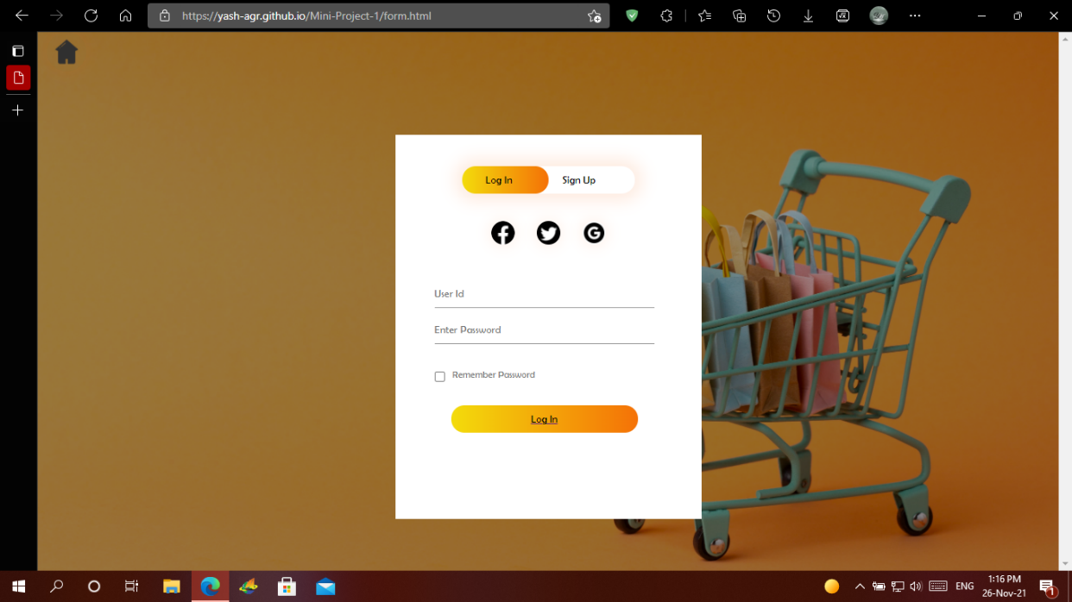

**Finished Auction Page**



**Currently Running Auction Page**

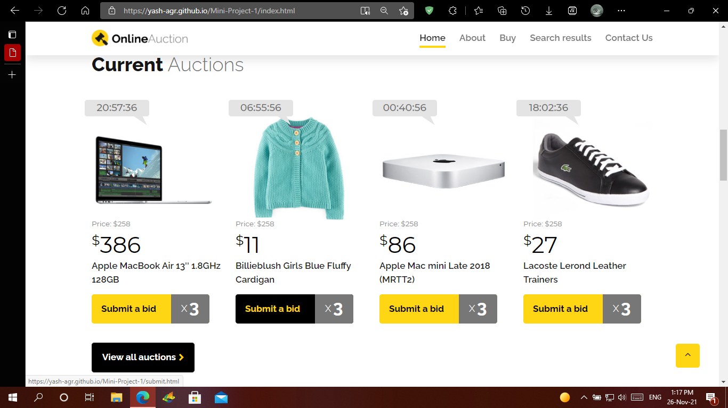

**Buy Details Page**



**Search And FAQ Pages**

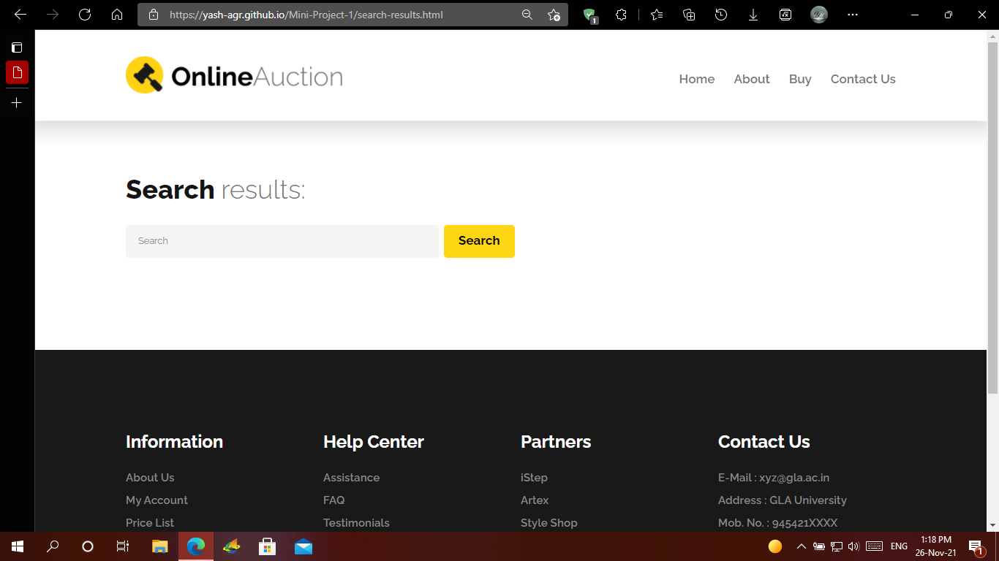

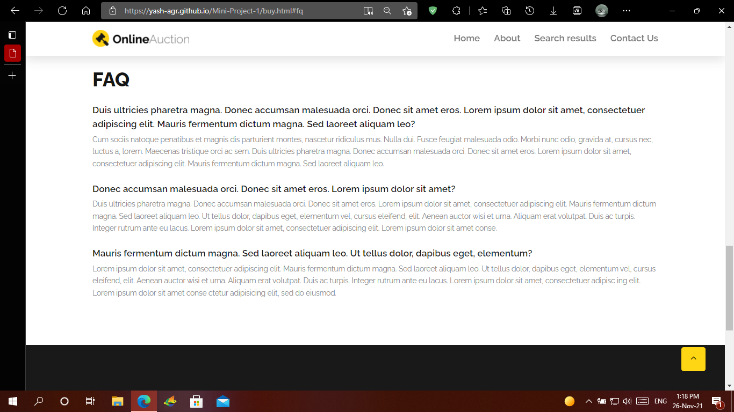

**Contact Us Page**

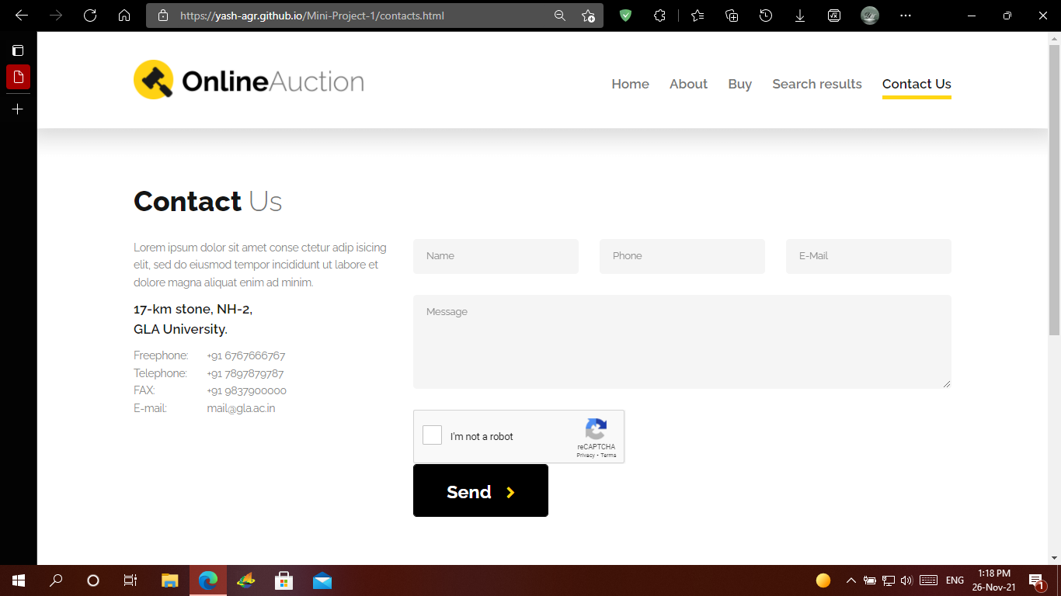

**Chapter 4**

**Software Testing**

Once source code has been generated, software must be tested to uncover as many errors as possible before delivery. It is very important to work the system successfully and achieve high quality of software. Testing include designing a series of test cases that have a high likelihood of finding errors by applying software-testing techniques. System testing makes logical assumptions that if all the parts of the system are correct, the goal will be successfully achieved. The system should be checked logically. Validations and cross checks should be there. Avoid duplications of record that cause redundancy of data. In other Words, Testing is the process of evaluating a system or its component(s) with the intent to find whether it satisfies the specified requirements or not. It is executing a system in order to identify any gaps, errors, or missing requirements in contrary to the actual requirements.

The preliminary goal of implementation is to write source code and internal documentation so that conformance of the code to its specifications can be easily verified, and so that debugging, testing and modifications are eased. This goal can be achieved by making the source code as clear and straightforward as possible. Simplicity, clarity and elegance are the hallmark of good programs, obscurity, cleverness, and complexity are indications of inadequate design and misdirected thinking. Source code clarity is enhanced by structured coding techniques, by good coding style, by, appropriate supporting documents, by good internal comments, and by feature provided in modern programming languages. The implementation team should be provided with a well-defined set of software requirement, an architectural design specification, and a detailed design description. Each team member must understand the objectives of implementation.

4.1 TERMINOLOGY

Error The term error is used in two ways. It refers to the difference between the actual output of software and the correct output, in this interpretation, error is essential a measure of the difference between actual and ideal. Error is also to used to refer to human action that result in software containing a defect or fault.

Fault is a condition that causes to fail in performing its required function. A fault is a basic reason for software malfunction and is synonymous with the commonly used term Bug.

Failure is the inability of a system or component to perform a required function according to its specifications. A software failure occurs if the behavior of the software is the different from the specified behavior. Failure may be caused due to functional or performance reasons.

4.2 TYPES OF TESTING

**a. Unit Testing**The term unit testing comprises the sets of tests performed by an individual programmer prior to integration of the unit into a larger system. A program unit is usually small enough that the programmer who developed it can test it in great detail, and certainly in greater detail than will be possible when the unit is integrated into an evolving software product. In the unit testing the programs are tested separately, independent of each other. Since the check is done at the program level, it is also called program teasing.

**b. Module Testing**A module and encapsulates related component. So can be tested without other system module.

**c. Subsystem Testing**Subsystem testing may be independently design and implemented common problems are sub-system interface mistake in this checking we concenton it. There are four categories of tests that a programmer will typically perform on a program unit.

i Functional test

ii Performance test

iii Stress test

iv Structure test

**Functional Test**Functional test cases involve exercising the code with Nominal input values for which expected results are known; as well as boundary values (minimum values, maximum values and values on and just outside the functional boundaries) and special values.

**Performance Test**Performance testing determines the amount of execution time spent in various parts of the unit, program throughput, response time, and device utilization by the program unit. A certain amount of avoid expending too much effort on fine-tuning of a program unit that contributes little to the overall performance of the entire system. Performance testing is most productive at the subsystem and system levels.

**Stress Test** Stress test are those designed to intentionally break the unit. A great deal can be learned about the strengths and limitations of a program by examining the manner in which a program unit breaks.

**Structure Test** Structure tests are concerned with exercising the internal logic of a program and traversing particular execution paths. Some authors refer collectively to functional performance and stress testing as “black box” testing. While structure testing is referred to as “white box” or “glass box” testing. The major activities in structural testing are deciding which path to exercise, deriving test date to exercise those paths, determining the test coverage criterion to be used, executing the test, and measuring the test coverage achieved when the test cases are exercised.

**Chapter 5**

**Conclusion**

We have completed our project within time limit with the coordination of our team members under the supervision of our mentor Dr. Manoj Varshney.

Our project repository is available at

https://github.com//

**Chapter 6**

**Bibliography**

[**www.google.com**](http://www.google.com)

**www.geeksforgeeks.org**

[**www.youtube.com**](http://www.youtube.com)

[**www.w3schools.com**](http://www.w3schools.com)

**www.wikipedia.com**